# **FACIAL EMOTION RECOGNITION**

# **Soumyadeep Pandit, Humant Sattabhayya, Rajat Arya**

[panditdeep9@gmail.com](mailto:panditdeep9@gmail.com), [aryan.rajat916@gmail.com](mailto:aryan.rajat916@gmail.com), [humantsattabhayya@gmail.com](mailto:humantsattabhayya@gmail.com)

**Data science trainees,**

Alma Better, Bangalore.

**Abstract:**

A Facial expression is the visible manifestation of the affective state, cognitive activity, intention, personality and psychopathology of a person and plays a communicative role in interpersonal relations. Automatic recognition of facial expressions can be an important component of natural human-machine interfaces; it may also be used in behavioral science and in clinical practice. An automatic Facial Expression Recognition system needs to perform detection and location of faces in a cluttered scene, facial feature extraction, and facial expression classification. Facial expression recognition system is implemented using Convolution Neural Network (CNN). CNN model of the project is based on LeNet Architecture. Kaggle facial expression dataset with seven facial expression labels as happy, sad, surprise, fear, anger, disgust, and neutral is used in this project. The system achieved 70 % accuracy and on training dataset, and 56% on text dataset.

***Keywords: Facial Expression Recognition, Convolutional Neural Network, Deep Learning,***

**1.Problem Statement:**

The Indian education landscape has been undergoing rapid changes for the past 10 years owing to the advancement of web-based learning services, specifically, eLearning platforms. Global E-learning is estimated to witness an 8X over the next 5 years to reach USD 2B in 2021. India is expected to grow with a CAGR of 44% crossing the 10M users mark in 2021. Although the market is growing on a rapid scale, there are major challenges associated with digital learning when compared with brick and mortar classrooms. One of many challenges is how to ensure quality learning for students. Digital platforms might overpower physical classrooms in terms of content quality but when it comes to understanding whether students are able to grasp the content in a live class scenario is yet an open-end challenge. In a physical classroom during a lecturing teacher can see the faces and assess the emotion of the class and tune their lecture accordingly, whether he is going fast or slow. He can identify students who need special attention. Digital classrooms are conducted via video telephony software program (exZoom) where it’s not possible for medium scale class (25-50) to see all students and access the mood. Because of this drawback, students are not focusing on content due to lack of surveillance. While digital platforms have limitations in terms of physical surveillance but it comes with the power of data and machines which can work for you. It provides data in the form of video, audio, and texts which can be analysed using deep learning algorithms. Deep learning backed system not only solves the surveillance issue, but it also removes the human bias from the system, and all information is no longer in the teacher’s brain rather translated in numbers that can be analysed and tracked.

We will solve the above-mentioned challenge by applying deep learning algorithms to live video data. The solution to this problem is by recognizing facial emotions.

**Face Emotion Recognition**: This is a few shot learning live face emotion detection system. The model should be able to real-time identify the emotions of students in a live class.

**1.1. Data Set Information:**

We have built a deep learning model which detects the real time emotions of students through a webcam so that teachers can understand if students are able to grasp the topic according to students' expressions or emotions and then deploy the model. The model is trained on the FER-2018 dataset .This dataset consists of 35887 grayscale, 48x48 sized face images with seven emotions - angry, disgusted, fearful, happy, neutral, sad and surprised. Here is the dataset link:-

<https://www.kaggle.com/jonathanoheix/face-expression-recognition-dataset>

**2. Introduction:**

Emotion recognition is the process of identifying human emotion. People vary widely in their accuracy at recognizing the emotions of others. Use of technology to help people with emotion recognition is a relatively nascent research area. Generally, the technology works best if it uses multiple modalities in context. To date, the most work has been conducted on automating the recognition of facial expressions from video, spoken expressions from audio, written expressions from text, and physiology as measured by wearables.

The accuracy of emotion recognition is usually improved when it combines the analysis of human expressions from multimodal forms such as texts, physiology, audio, or video. Different emotion types are detected through the integration of information from facial expressions, body movement and gestures, and speech. The technology is said to contribute in the emergence of the so-called emotional or emotive Internet.

The existing approaches in emotion recognition to classify certain emotion types can be generally classified into three main categories: knowledge-based techniques, statistical methods, and hybrid approaches.Knowledge-based techniques (also known as lexicon-based techniques) use domain knowledge as well as semantic and syntactic properties of language to detect specific emotion types. During the emotion classification process, it is common to use knowledge-based resources such as WordNet, SenticNet, ConceptNet, and EmotiNet, to name a few. One of the benefits of this approach is the ease of access and cost-effectiveness provided by the abundance of such knowledge-based resources. However, one limitation of this technique is its inability to handle concept nuances and complex linguistic rules.

There are two types of knowledge-based techniques: dictionary-based approaches and corpus-based approaches.

Dictionary-based approaches look up opinion or emotion seed words in a dictionary and look up synonyms and antonyms to expand the initial list of opinions or emotions.

## **3. Methodology:**

In machine learning, a convolutional neural network (CNN, or ConvNet) is a type of feedforward artificial neural network in which the connectivity pattern between its neurons is inspired by the organization of the animal visual cortex. Individual cortical neurons respond to stimuli in a restricted region of space known as the receptive field. The receptive fields of different neurons partially overlap such that they tile the visual field. The response of an individual neuron to stimuli within its receptive field can be approximated mathematically by a convolution operation. Convolutional networks were inspired by biological processes and are variations of multilayer perceptron designed to use minimal amounts of preprocessing. They have wide applications in image and video recognition, recommender systems and natural language processing. The convolutional neural network is also known as shift invariant or space invariant artificial neural network (SIANN), which is named based on its shared weights architecture and translation invariance characteristics. LeNet is one of the very first convolutional neural networks which helped propel the field of Deep Learning. This pioneering work by Yann LeCun was named LeNet5 was used mainly for character recognition tasks such as reading zip codes, digits, etc.

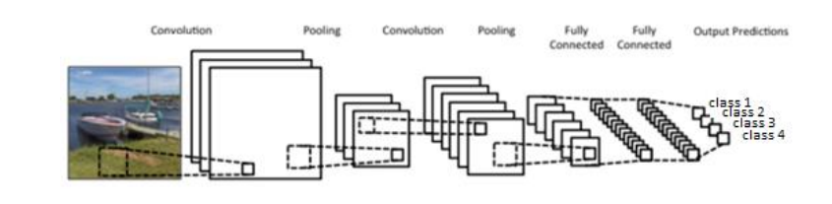

Figure 3.1 A model of CNN

There are four main operations in the Convolution Neural Network shown in Figure 3.1 above:

**1. Convolution:**

The primary purpose of Convolution in case of a CNN is to extract features from the input image. Convolution preserves the spatial relationship between pixels by learning image features using small squares of input data. The convolution layer’s parameters consist of a set of learnable filters. Every filter is small spatially (along width and height), but extends through the full depth of the input volume. For example, a typical filter on a first layer of a CNN might have size 3x5x5 (i.e. images have depth 3 i.e. the color channels, 5 pixels width and height). During the forward pass, each filter is convolved across the width and height of the input volume and compute dot products between the entries of the filter and the input at any position. As the filter convolve over the width and height of the input volume it produces a 2-dimensional activation map that gives the responses of that filter at every spatial position. Intuitively, the network will learn filters that activate when they see some type of visual feature such as an 3 edge of some orientation or a blotch of some color on the first layer, or eventually entire honeycomb or wheel-like patterns on higher layers of the network. Now, there will be an entire set of filters in each convolution layer (e.g. 20 filters), and each of them will produce a separate 2-dimensional activation map.

The 2-dimensional convolution between image A and Filter B can be given as:

𝐶(𝑖,𝑗) = ∑ ∑ 𝐴(𝑚, 𝑛) ∗ 𝐵(𝑖 − 𝑚,𝑗 − 𝑛) 𝑁𝑎−1 𝑛=0 𝑀𝑎−1 𝑚=0

where size of A is (Ma x Na), size of B is (Mb x Nb), 0 ≤ 𝑖 < 𝑀𝑎 + 𝑀𝑏 −1 ∧ 0 ≤ 𝑗 < 𝑁𝑎 + 𝑁𝑏 − 1

A filter convolves with the input image to produce a feature map. The convolution of another filter over the same image gives a different feature map. Convolution operation captures the local dependencies in the original image. A CNN learns the values of these filters on its own during the training process (although parameters such as number of filters, filter size, architecture of the network etc. still needed to specify before the training process). The more number of filters, the more image features get extracted and the better network becomes at recognizing patterns in unseen images.

The size of the Feature Map (Convolved Feature) is controlled by three parameters

* Depth: Depth corresponds to the number of filters we use for the convolution operation.
* Stride: Stride is the size of the filter, if the size of the filter is 5x5 then stride is 5.
* Zero-padding: Sometimes, it is convenient to pad the input matrix with zeros around the border, so that filter can be applied to bordering elements of input image matrix. Using zero padding size of the feature map can be controlled.

**2. Rectified Linear Unit**:

An additional operation called ReLU has been used after every Convolution operation. A Rectified Linear Unit (ReLU) is a cell of a neural network which uses the following activation function to calculate its output given x:

R(x) = Max(0,x)

Using these cells is more efficient than sigmoid and still forwards more information compared to binary units. When initializing the weights uniformly, half of the weights are negative. This 4 helps creating a sparse feature representation. Another positive aspect is the relatively cheap computation. No exponential function has to be calculated. This function also prevents the vanishing gradient error, since the gradients are linear functions or zero but in no case nonlinear functions.

**3. Pooling (sub-sampling):**

Spatial Pooling (also called subsampling or downsampling) reduces the dimensionality of each feature map but retains the most important information. Spatial Pooling can be of different types: Max, Average, Sum etc. In case of Max Pooling, a spatial neighborhood (for example, a 2×2 window) is defined and the largest element is taken from the rectified feature map within that window. In case of average pooling the average or sum of all elements in that window is taken. In practice, Max Pooling has been shown to work better.

Max Pooling reduces the input by applying the maximum function over the input xi. Let m be the size of the filter, then the output calculates as follows:

M(𝑥𝑖) = 𝑚𝑎𝑥 {𝑥𝑖+𝑘,+𝑙 |𝑘| ≤ 𝑚/2 , |𝑙| ≤ 𝑚/2 𝑘, 𝑙𝜖 ℕ} 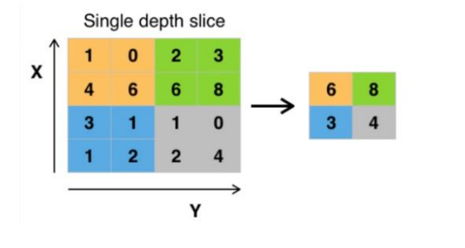

Fig 3.2

The function of Pooling is to progressively reduce the spatial size of the input representation. In particular, pooling

* Makes the input representations (feature dimension) smaller and more manageable
* Reduces the number of parameters and computations in the network, therefore, controlling over-fitting
* Makes the network invariant to small transformations, distortions and translations in the input image (a small distortion in input will not change the output of Pooling.
* Helps us arrive at an almost scale invariant representation. This is very powerful since objects can be detected in an image no matter where they are located.

**4. Classification (Multilayer Perceptron):**

The Fully Connected layer is a traditional Multi-Layer Perceptron that uses a softmax activation function in the output layer. The term “Fully Connected” implies that every neuron in the previous layer is connected to every neuron on the next layer. The output from the convolutional and pooling layers represent high-level features of the input image. The purpose of the Fully Connected layer is to use these features for classifying the input image into various classes based on the training dataset.

The facial expression recognition system is implemented using convolutional neural network. The block diagram of the system is shown in following figures:

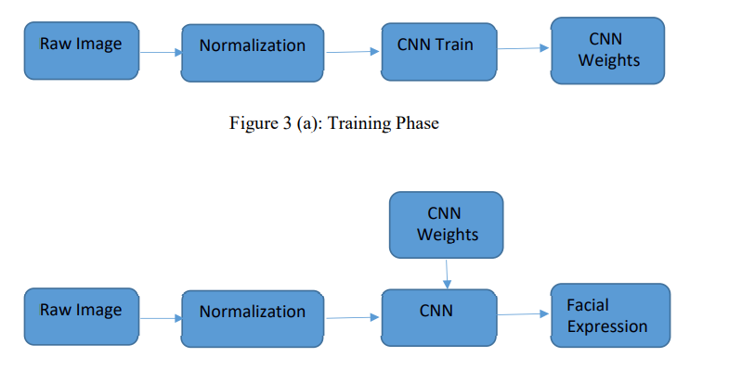

During training, the system received a training data comprising grayscale images of faces with their respective expression label and learns a set of weights for the network. The training step took as input an image with a face. Thereafter, an intensity normalization is applied to the image. The normalized images are used to train the Convolutional Network. To ensure that the training performance is not affected by the order of presentation of the examples, validation dataset is used to choose the final best set of weights out of a set of trainings performed with samples presented in different orders. The output of the training step is a set of weights that achieve the best result with the training data. During test, the system received a grayscale image of a face from test dataset, and output the predicted expression by using the final network weights learned during training. Its output is a single number that represents one of the seven basic expressions.

**4. Architecture of CNN:**

A typical architecture of a convolutional neural network contains an input layer, some convolutional layers, some fully-connected layers, and an output layer. CNN is designed with some modification on LeNet Architecture. It has 6 layers without considering input and output. The architecture of the Convolution Neural Network used in the project is shown in the following figure.

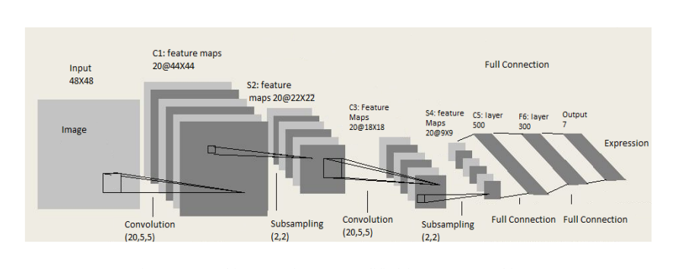

Fig 4.1 Architecture of CNN ( Modified from LeNet Architecture)

**1. Input Layer:** The input layer has pre-determined, fixed dimensions, so the image must be pre-processed before it can be fed into the layer. Normalized gray scale images of size 48 X 48 pixels from Kaggle dataset are used for training, validation and testing. For testing propose laptop webcam images are also used, in which face is detected and cropped using OpenCV Haar Cascade Classifier and normalized.

**2. Convolution and Pooling (ConvPool) Layers:** Convolution and pooling is done based on batch processing. Each batch has N images and CNN filter weights are updated on those batches. Each convolution layer takes image batch input of four dimension N x Color-Channel x width x height. Feature map or filter for convolution are also four dimensional (Number of feature maps in, number of feature maps out, filter width, filter height). In each convolution layer, four dimensional convolution is calculated between image batch and feature maps. After convolution only parameter that change is image width and height.

New image width = old image width – filter width + 1 New image height = old image height – filter height + 1

After each convolution layer downsampling / subsampling is done for dimensionality reduction. This process is called Pooling. Max pooling and Average Pooling are two famous pooling method. In this project max pooling is done after convolution. Pool size of (2x2) is 12 taken, which splits the image into grid of blocks each of size 2x2 and takes maximum of 4 pixels. After pooling only height and width are affected.

Two convolution layer and pooling layer are used in the architecture. At first convolution layer size of input image batch is Nx1x48x48. Here, size of image batch is N, number of color channel is 1 and both image height and width are 48 pixel. Convolution with feature map of 1x20x5x5 results image batch is of size Nx20x44x44. After convolution pooling is done with pool size of 2x2, which results image batch of size Nx20x22x22. This is followed by second convolution layer with feature map of 20x20x5x5, which results image batch of size Nx20x18x18. This is followed by pooling layer with pool size 2x2, which results image batch of size Nx20x9x9.

**3. Fully Connected Layer:** This layer is inspired by the way neurons transmit signals through the brain. It takes a large number of input features and transform features through layers connected with trainable weights. Two hidden layers of size 500 and 300 unit are used in fully-connected layer. The weights of these layers are trained by forward propagation of training data then backward propagation of its errors. Back propagation starts from evaluating the difference between prediction and true value, and back calculates the weight adjustment needed to every layer before. We can control the training speed and the complexity of the architecture by tuning the hyper-parameters, such as learning rate and network density. Hyper-parameters for this layer include learning rate, momentum, regularization parameter, and decay. The output from the second pooling layer is of size Nx20x9x9 and input of first hidden layer of fully-connected layer is of size Nx500. So, output of pooling layer is flattened to Nx1620 size and fed to first hidden layer. Output from first hidden layer is fed to second hidden layer. Second hidden layer is of size Nx300 and its output is fed to output layer of size equal to number of facial expression classes.

**5. Deployment**

We have created two patterns for detecting and predicting single faces and as well as multiple faces using OpenCV videocapture in local. For Webapp , OpenCV can’t be used. Thus, using Streamlit-Webrtc for front-end application.

We have made a front end using streamlit .Streamlit doesn’t provide the live capture feature itself, instead uses a third party API. I have used streamlit-webrtc which helped to deal with real-time video streams. Image captured from the webcam is sent to VideoTransformer function to detect the emotion. Then this model was deployed on heroku and streamlit platform with the help of buildpack-apt which is necessary to deploy opencv model on heroku and streamlit. Fig 5.1 Happy (Humant)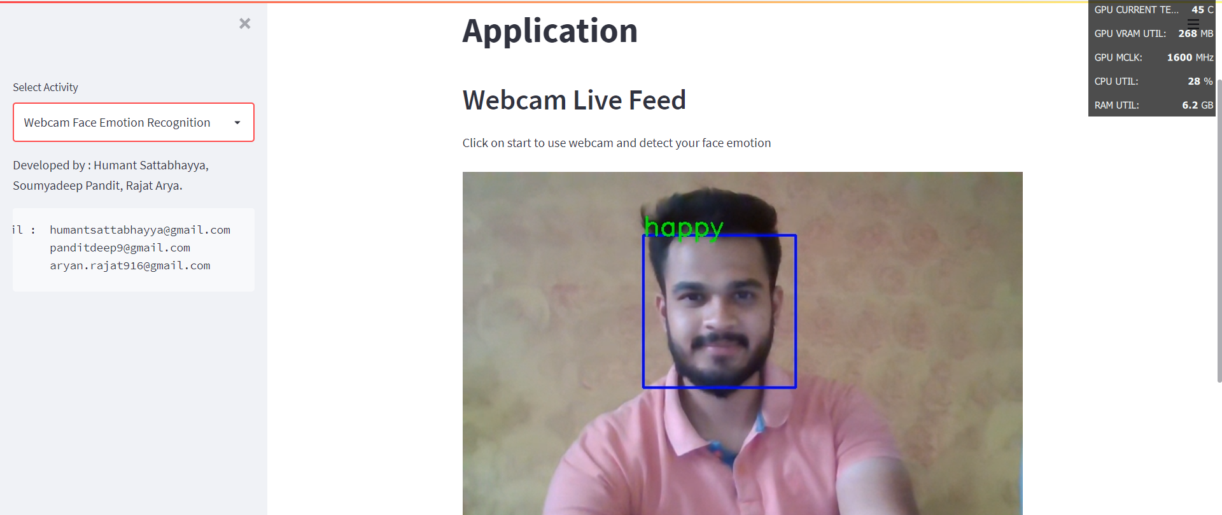

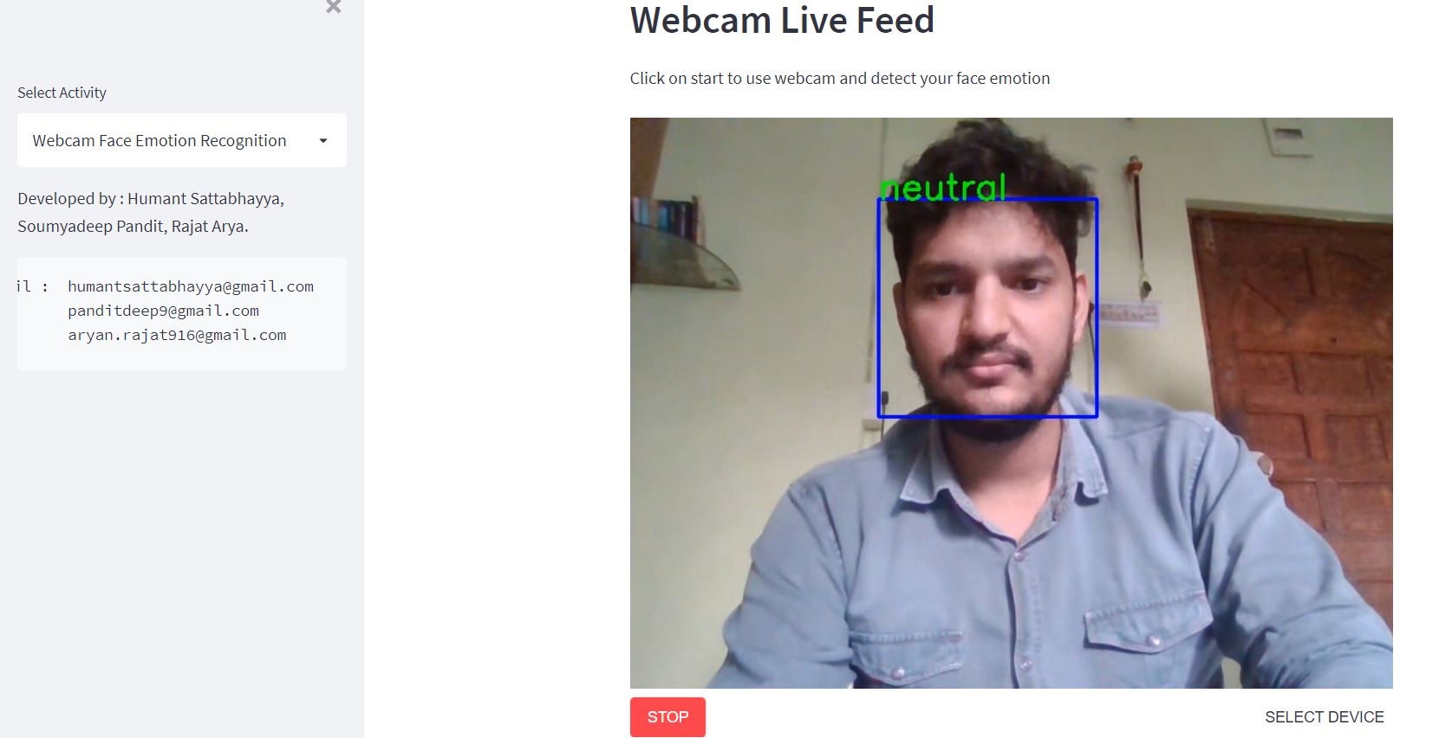

Fig 5.2 Neutral (Rajat)

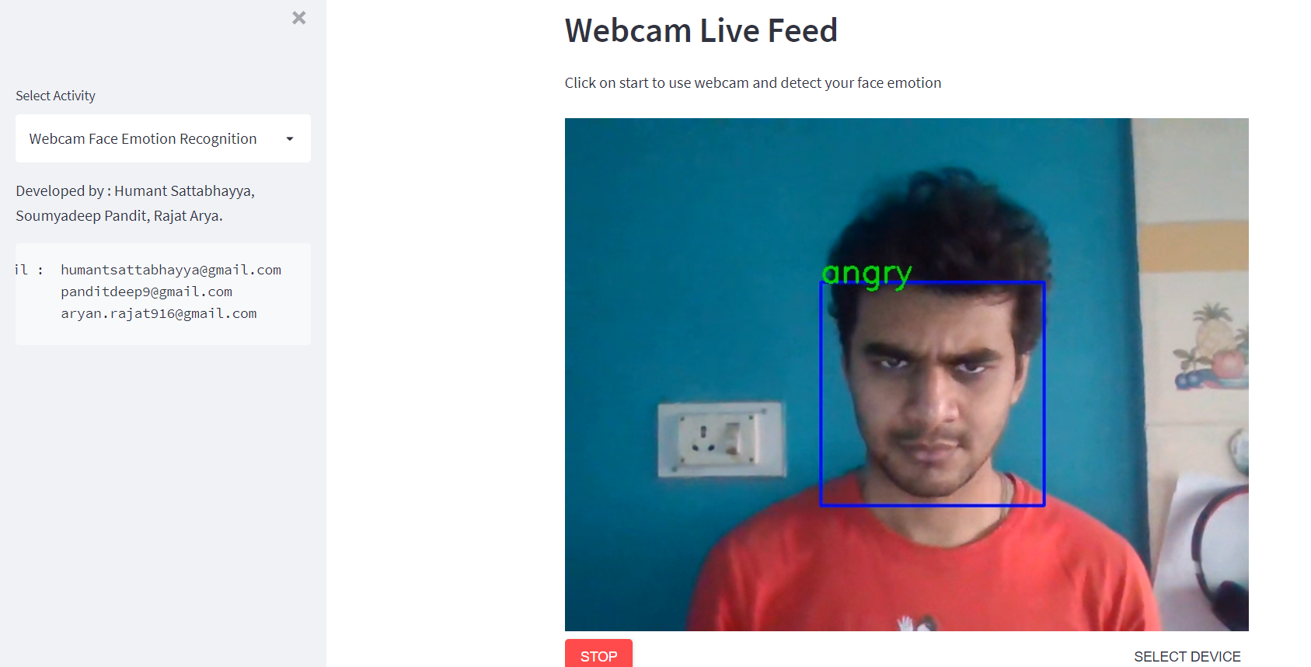

Fig 5.3 Angry (Soumyadeep)

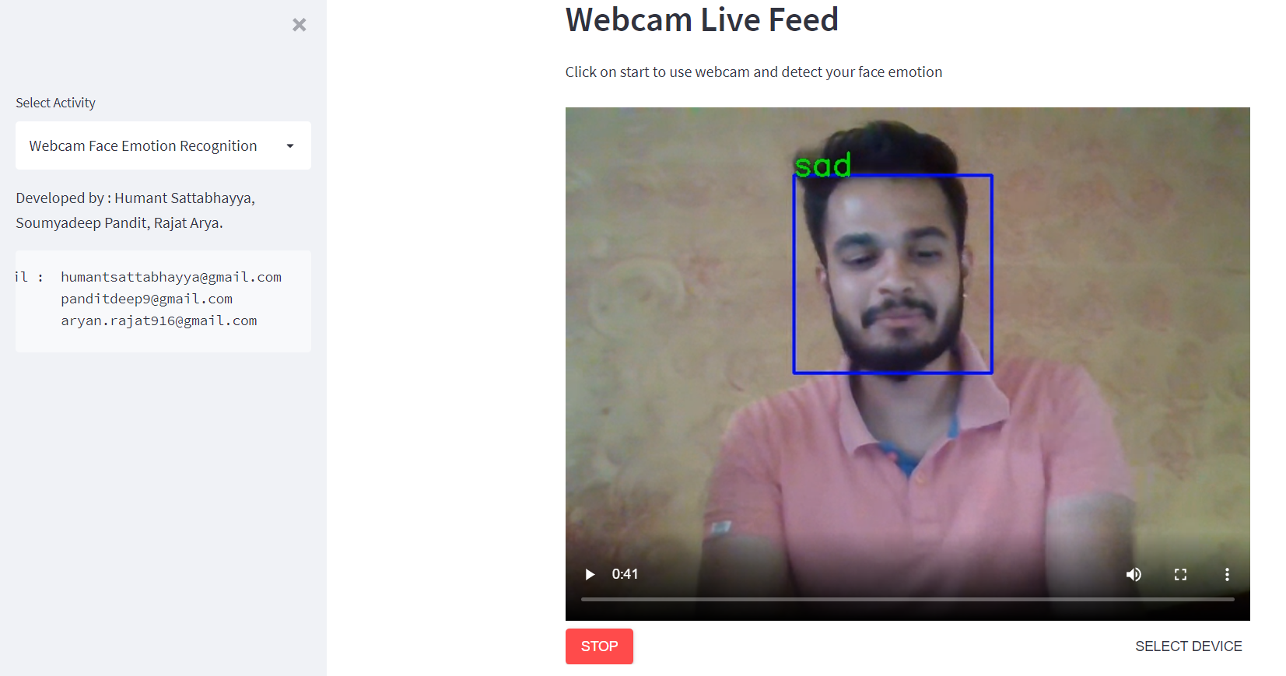

Fig 5.4 Sad (Humant)

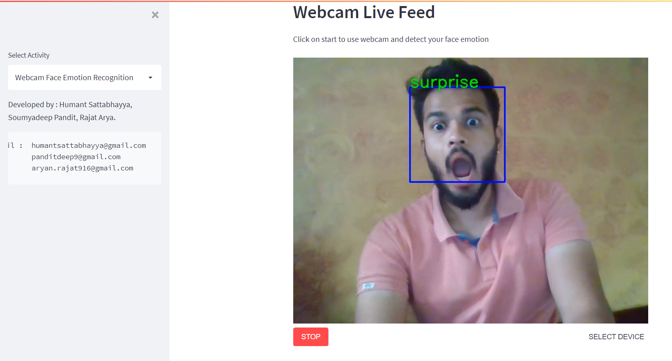

Fig 5.5 Surprised (Humant)

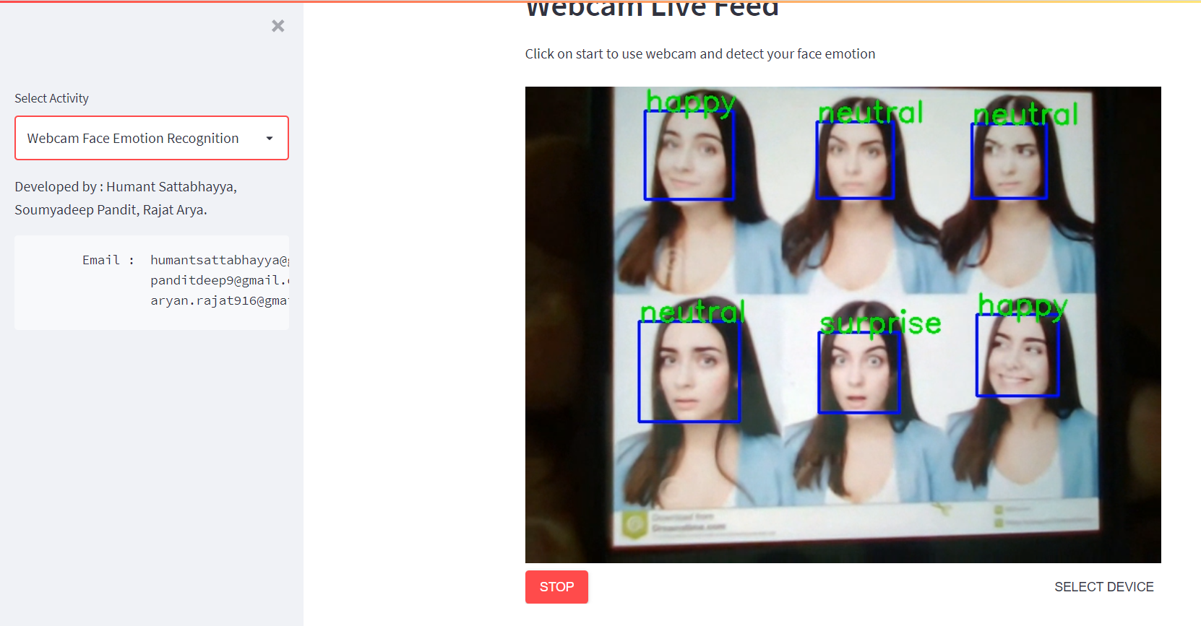

Fig 5.6 Multiple faces and expressions

Streamlit link: <http://192.168.221.127:8505>

Heroku link: <https://facial-emotion-recognition-py.herokuapp.com/>

**Conclusion:**

Finally We build the WebApp using streamlit and deployed on Heroku.

The model which was created using CNN that gave training accuracy of 80% and validation accuracy of 65%.

Model also works for multiple face detection.

**References-**

1. MachineLearningMastery
2. GeeksforGeeks
3. Analytics Vidhya
4. Towards DataScience
5. Data Science from scratch
6. Builtin
7. Plosone
8. Stremlit Documentation
9. Heroku Documentation
10. Tensorflow Documentation